Genesis Portal instructions

**How to Use the MHS GENESIS Patient Portal**

1. From the MHS GENESIS Patient Portal Dashboard, choose Messaging.

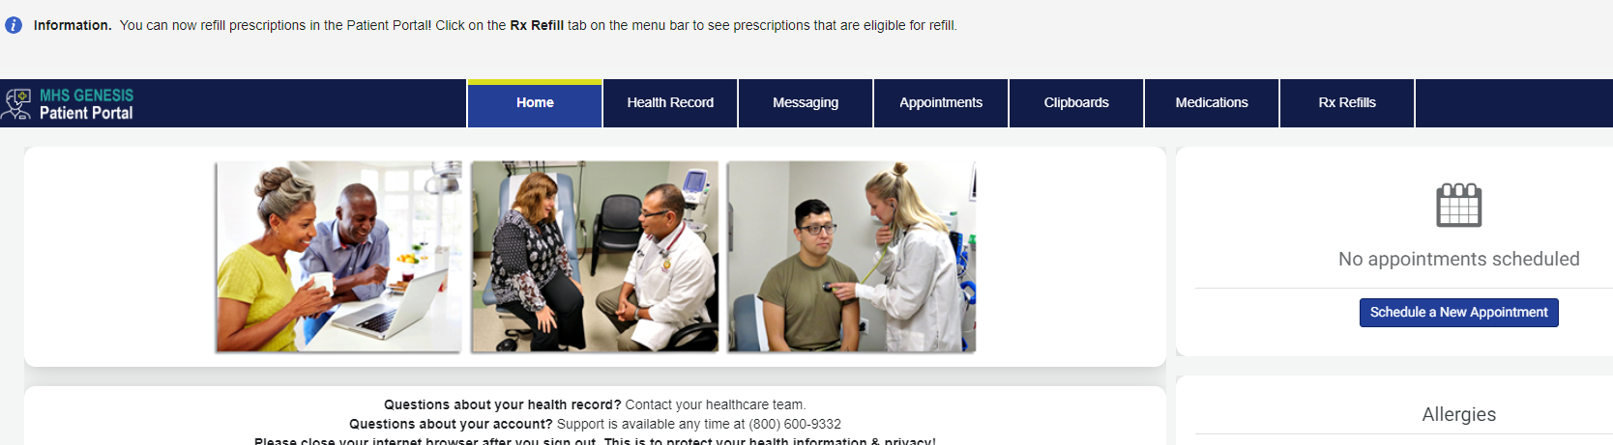

2. In the New Message menu, select "Send a message"

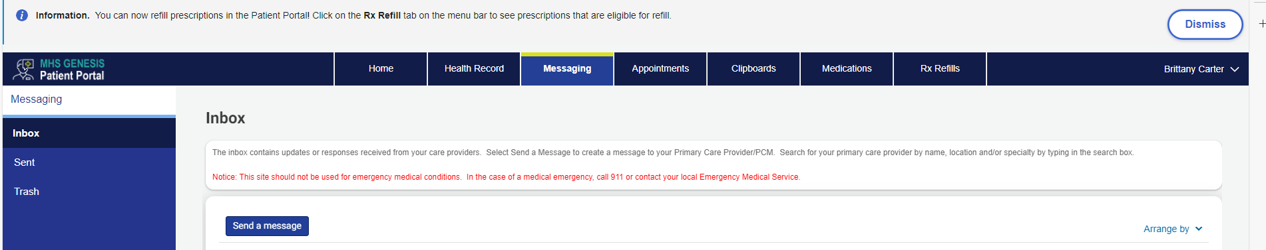

3. In the “To” field, search for the appropriate clinic name

**Ft. Cavazos Ophthalmology**

4. Type the subject – “Laser Surgery packet”, attach completed Laser Surgery Packet and write your message.

5. Click Send

